UNU-Commitment Ledger System Test – T1

Journal Import | Flat File Journal Import Request
Navigation:  General Ledger > Journals > Import Journals > External Flat Files  Add a new Run Control ID  Run Control ID – UNU_COMM_LED_ST_001  No File Attached | 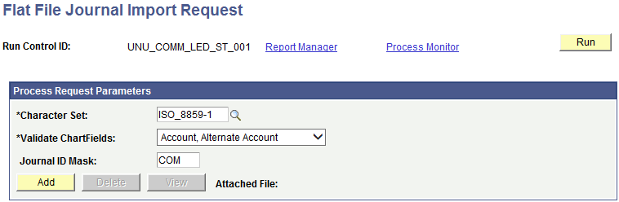
File has been attached.  Select Process – UN_JRNL_CNV | 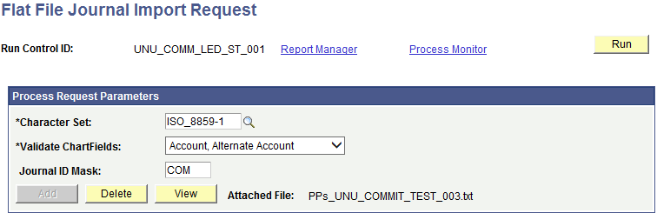  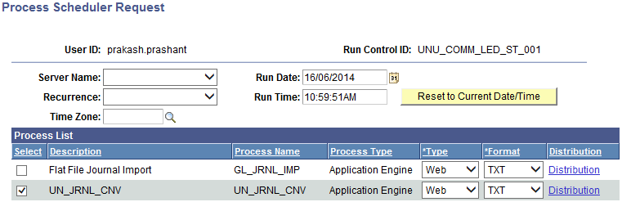  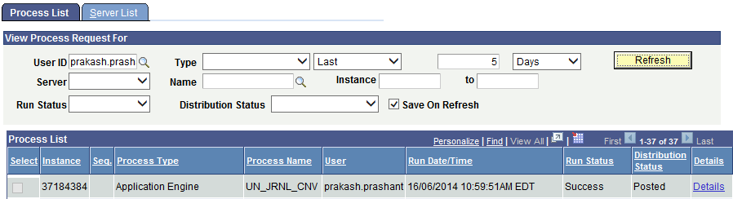
Check the Message Log to view the process logs | 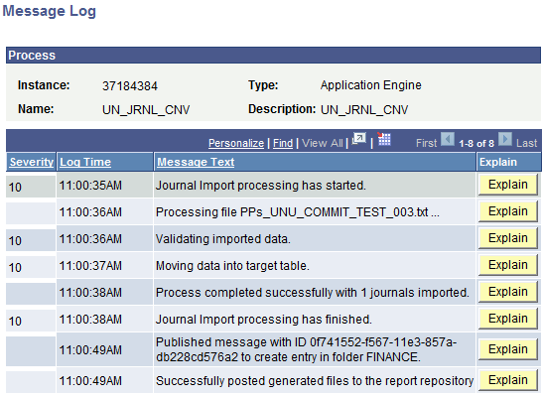  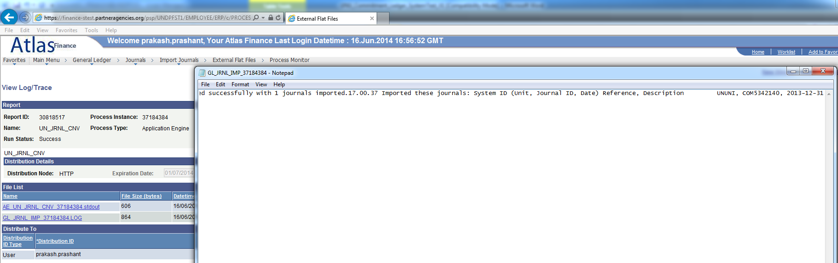

Journal | Edit Journal(s)
Navigation:  General Ledger > Journals > Journal Entry > Create/Update Journal Entries  View the Journal – UNUNI/COM5342140  The following message will pop-up  “The journal must be formatted by the Journal Edit process before you can use it here. (5010, 101)”  Click OK  Note. Journal entries loaded to your system using flat file journal import must be edited using batch edit only. This is important because, imported journals do not yet have all journal lines and values populated by the various automatic features associated with batch edit. Imported journals should not be edited online. After importing journals, if you open them online you get a warning message stating that they must be edited first. It is only after the batch edit that the journals display the final entries for such things as interunit journals, separate debit credit reversals, and multibook lines. | 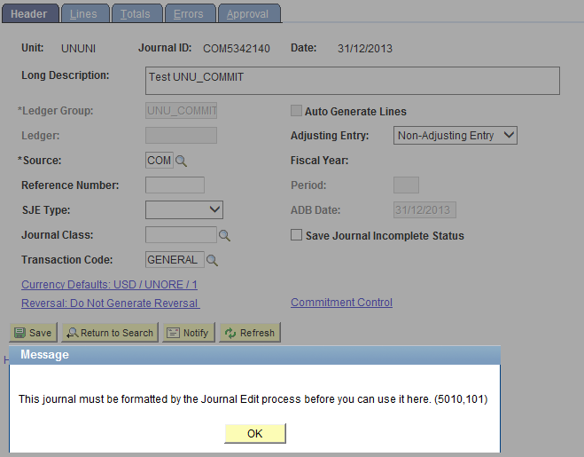  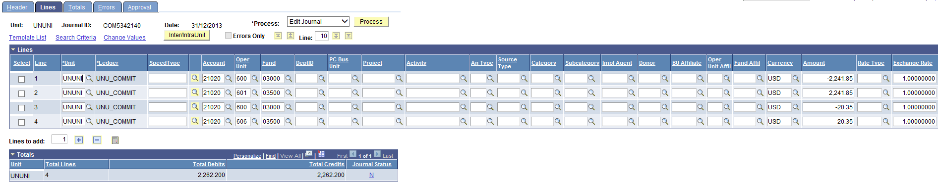
Navigation:  General Ledger > Journals > Process Journals > Edit Journals  Create a new Run Control ID  Select the Journal that you want to edit. Note the various parameters  Run PS/GL Journal Edit | 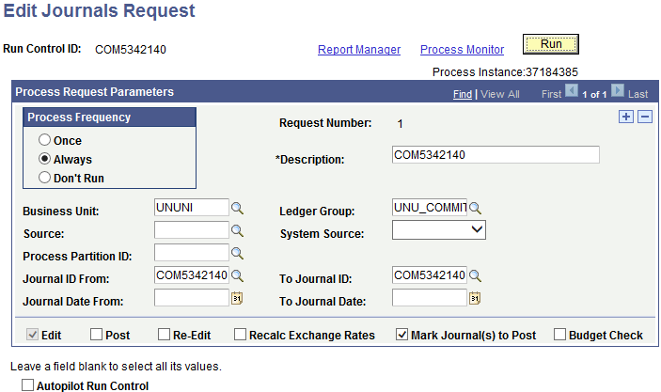
Open the Journal, and change the Reversal settings to “Beginning of Next Period”  Click Save  Edit/Post the Journal via Batch mode | 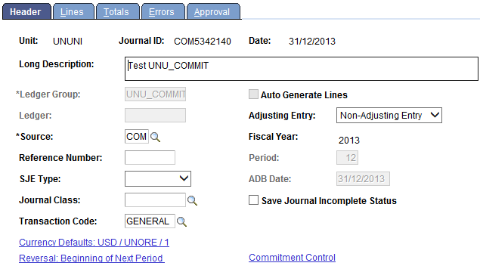  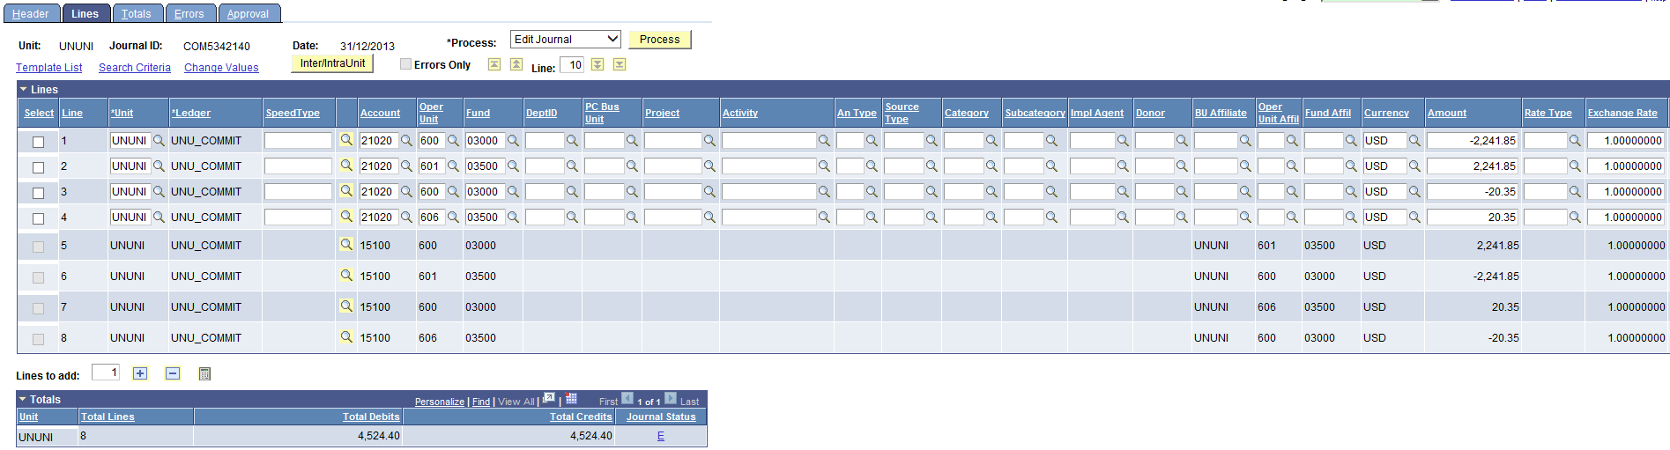

Steps to create the upload file | Journal Upload Template
Input values for fields:  HEADER  - Column F – ACCOUNTING_PERIOD – 12  - Column H – LEDGER_GROUP – UNU_COMMIT  - Leave column I blank  - Column O – SOURCE – COM  - Column V – SYSTEM_SOURCE – GOT  LINE  - Column C – leave it as NEXT, if you like to select a Journal Mask, do that on the run control page e.g., COM  - Column D – LEDGER – UNU_COMMIT  - Column AC – LINE_DESCR  - Input CoA’s, Budget Date and appropriate Amounts with exchange rate | 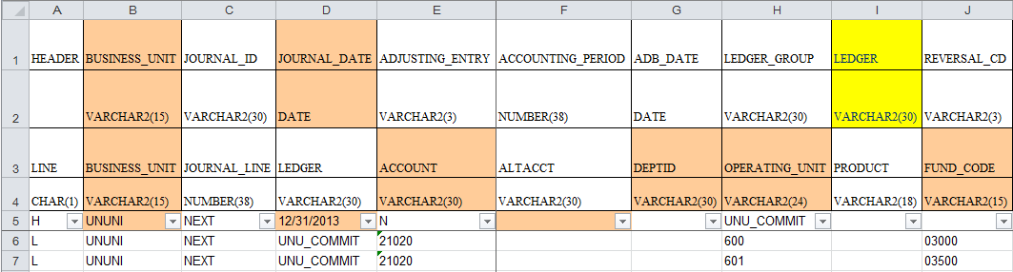  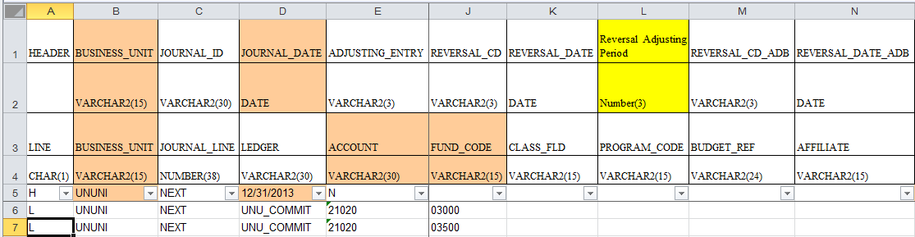  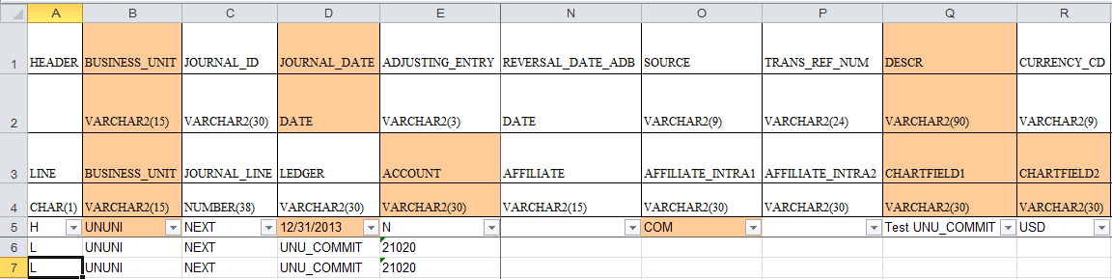  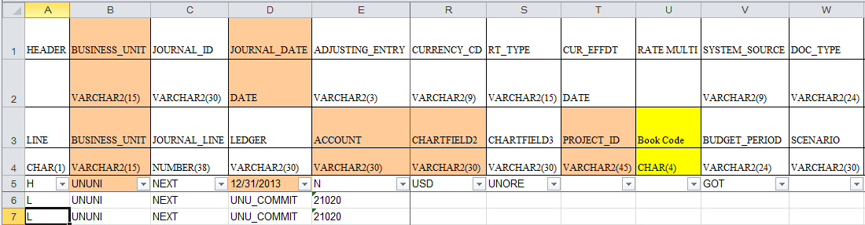  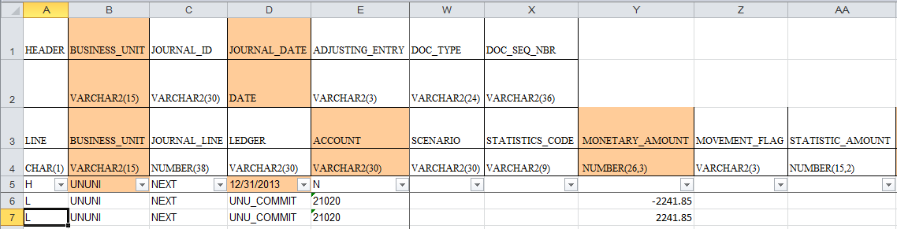
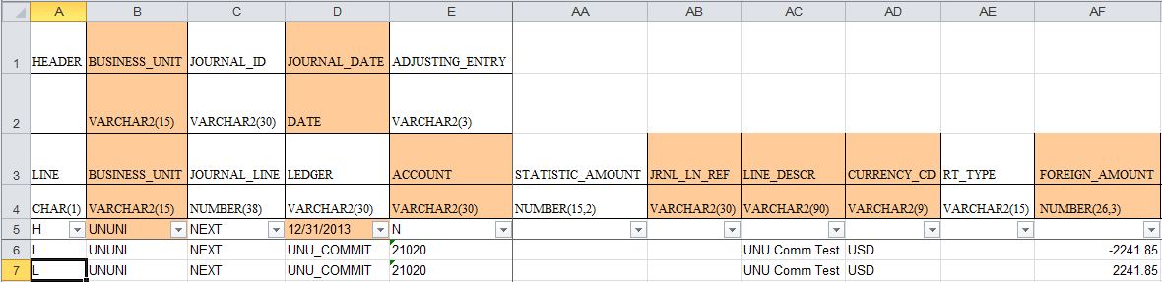

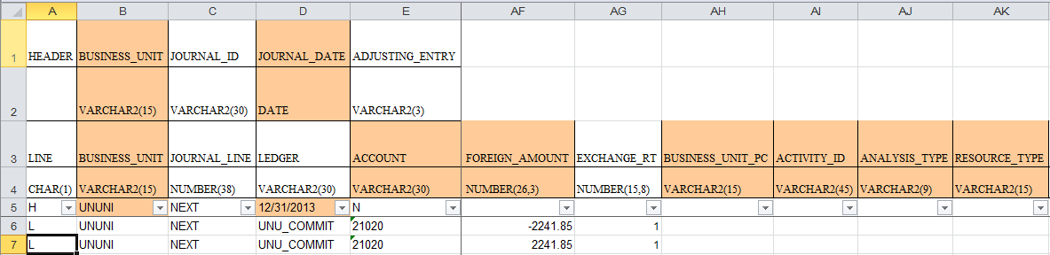

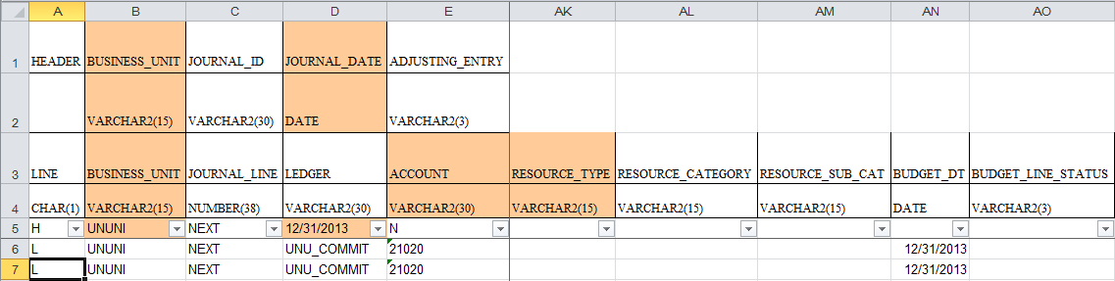

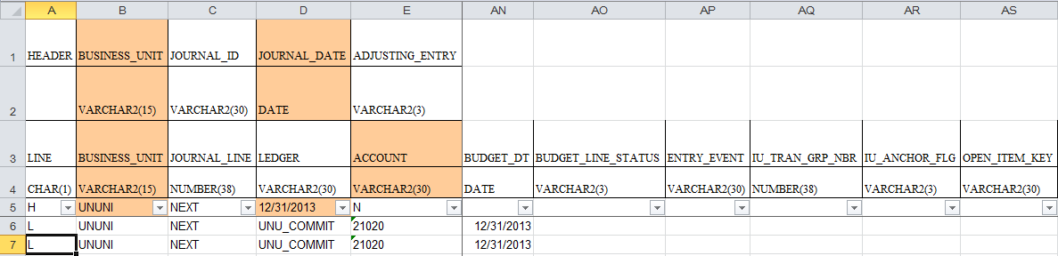

Journal | Edit Journal(s)
Navigation:  General Ledger > Journals > Journal Entry > Create/Update Journal Entries  View the Journal – UNUNI/COM5342171 | 